KARNATAK LAW SOCIETY'S
GOGTE INSTITUTE OF TECHNOLOGY

An Autonomous Institution under
Visvesvaraya Technological University, Belagavi

Activity Book

Interdisciplinary Project Work
(Activity-Based Learning)

Academic Year: 2025-26 Semester: 2

Student Name: Nishant Yadawad

Branch: Computer Science Engineering USN: 2GI25CS116

Team Name and Strength: 122
Mentor/Faculty Member Name: Prof Vivek Tiwari
Institute Name: K.L.S Gogte Institute of Technology, Belagavi.

KARNATAK LAW SOCIETY'S
GOGTE INSTITUTE OF TECHNOLOGY

An Autonomous Institution under
Visvesvaraya Technological University, Belagavi

Table of Contents

Week | Module Title | Activity Title | Page No. | Remarks
1–3 | Orientation, Team Formation and Literature Survey | Communication & Team  Activities
4 -6 | Problem Statement,  Multiple Solution IDEAS Selection of Best IDEA | Review of Interviews/Interaction Problem Tree, Ideation
7–9 | Prototyping: Stage - 1 | Theory of Prototyping  Building, Design, Structure, Coding
9–12 | Prototyping: Stage - 2 | Development of physical  /working Prototyping, Testing and Analysis
13–14 | Review of Users, Refining and Pre-final Review | Review of Limitations/Challenges
15–16 | Final Demo & Social Pitch | Innovation Pitch

KARNATAK LAW SOCIETY'S
GOGTE INSTITUTE OF TECHNOLOGY

An Autonomous Institution under
Visvesvaraya Technological University, Belagavi

- Write about Interdisciplinary Project Work

Interdisciplinary Project Work is a learning methodology in which students apply knowledge from different disciplines to solve real-world problems. It promotes innovation, teamwork, creativity, and practical learning. In this project, concepts from electronics, programming, mechanical design, and communication skills are integrated to develop a working prototype. The project helps students understand how different engineering and technology domains work together to create effective solutions. It also improves analytical thinking, project management, and presentation skills, preparing students for industrial and research environments.

- Brief about Literature Review

India holds the world's largest livestock population (535+ million, 20th Livestock Census, 2019), with diseases like FMD, Brucellosis, HS, BQ, and PPR causing annual losses exceeding ₹20,000 crore. The NADCP (2019) targets 100% FMD and Brucellosis coverage, yet field-level monitoring remains fragmented.
Studies (Bardhan et al., 2017; Singh et al., 2019) have documented field irregularities—ghost vaccinations, duplicate proof images, GPS tampering, and expired vial usage—in paper-based systems with minimal auditability. GPS-enabled verification for field workers (Duflo et al., 2012; Banerjee et al., 2016) has proven effective in reducing data fabrication by cross-checking assigned locations against actual coordinates.
Digital dashboards like WHO DHIS2 and INAPH enable real-time coverage visualization and anomaly detection, while client-side processing (SheetJS/XLSX) supports offline-first functionality for rural connectivity constraints. Cold-chain integrity monitoring through IoT loggers and digital audit trails (Chiodini, 2014; PATH, 2020) ensures vaccines remain within the 2–8°C range.
Key Gap: Existing platforms lack integrated fraud-signal scoring combining GPS mismatch, duplicate images, impossible speed, and expired vials into a weighted risk score—which VaxLivestock addresses alongside real-time district compliance mapping and officer workload visibility.

- Brief about Intellectual Property Rights (IPR)
VaxLivestock is an original software product with IP spanning the following categories:
A. Copyright: The source code (HTML, CSS, JS), fraud-scoring algorithm, client-side parser, and UI design are protectable as literary and artistic works under the Indian Copyright Act, 1957 (Section 2(o)). Registration with the Copyright Office, New Delhi is optional but provides prima facie ownership evidence.
B. Trade Secret: The weighted fraud-signal scoring engine (GPS mismatch +40, speed anomaly +20, duplicate image +30, expired vaccine +50) constitutes a proprietary methodology best protected as a trade secret, as the specific weights are difficult to reverse-engineer from the UI.
C. Trademark: "VaxLivestock" and its logo are eligible for registration under the Trade Marks Act, 1999 (Class 9 — software; Class 42 — SaaS).
D. Patent: Software per se is not patentable in India (Section 3(k), Patents Act, 1970), but a "technical effect" claim could be explored for the integrated GPS + time-series anomaly detection method applied to vaccination fraud.
E. Database Rights: The structured vaccination dataset schema and district compliance aggregation are protectable as a database compilation under copyright.
F. Open-Source: Libraries used (TailwindCSS, SheetJS) are permissively licensed (MIT/Apache 2.0) with no copyleft obligations. Proper attribution is maintained.

Week 1–3: Orientation & Team Formation (additional sheets may be attached, if required)
  - Activity Title: Understanding Karnataka's Livestock Vaccination Ecosystem & Team Formation
  - Objective: To study existing vaccination workflows, identify fraud and monitoring gaps, and form a team with defined roles.

  - Tasks Done:

- Researched NADCP programme and Karnataka vaccination statistics (FMD, Brucellosis, HS+BQ, PPR)
- Studied existing portals (INAPH, e-Pashuhaat) — found no fraud detection or GPS validation features
- Analyzed sample Excel vaccination records and understood the column structure
- Formed a 4-member team: UI/UX lead, frontend developer, data/testing lead, documentation lead

  - Sketching and Problem Tree Analysis or Drawing:

- Root Problem: No transparent, fraud-resistant digital monitoring of livestock vaccination drives
- Causes: Paper records, no GPS checks, no image deduplication, no expiry validation, no real-time dashboard
- Effects: Public health risk, financial loss, farmer trust erosion, unreliable coverage data

  - Faculty Signature with remarks

Week 4–6: Problem Statement, Multiple Solution IDEAS Selection of Best IDEA
  - Problem Statement: Karnataka's Animal Husbandry Dept. lacks a digital platform to detect vaccination fraud (GPS tampering, duplicate proofs, expired vaccines) and monitor district-level compliance in real-time.

  - Key Observations:

- 60%+ field records submitted via plain Excel with zero validation.
- GPS data never cross-referenced with assigned villages.
- Proof images reused across multiple animal IDs.
- No consolidated dashboard for district officers.

  - Multiple Solution IDEAS:

- VaxLivestock Web Dashboard — Client-side Excel processing + fraud scoring engine + compliance dashboard (Selected)
- Mobile Field App — Native Android app for data collection with GPS capture
- Blockchain Ledger — Tamper-proof vaccination records, but high infrastructure cost
- SMS/USSD System — Low-tech reporting, but no GPS/image/fraud capability

  - Photos / Sketches: (Paste or attach)

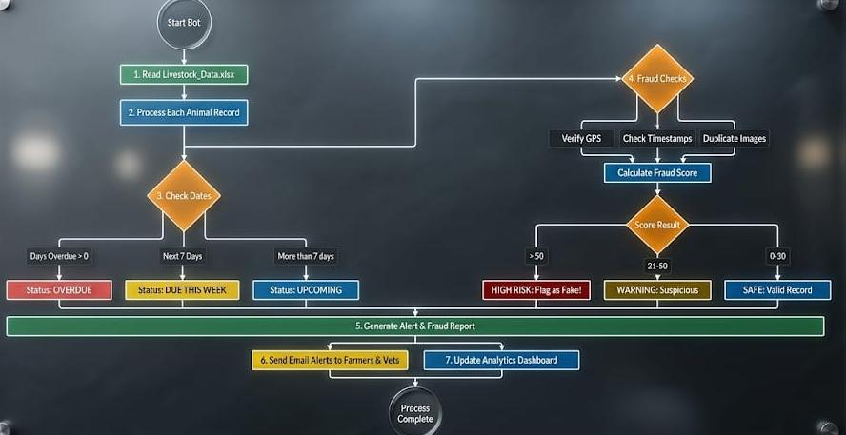

  - Challenges Noted:

Challenges Noted: Balancing offline usability with feature richness; defining fraud-signal weights that minimize false positives.

  - Faculty Feedback & Signature:

Week 7–9: Prototyping: Stage - 1
  - IDEA selected for Protype development:

IDEA Selected: VaxLivestock Web Dashboard — single-page app with client-side Excel parsing, fraud detection engine, and multi-view dashboard.

  - Justification for Selection:
- Works with existing Excel workflows — no change needed for field officers
- Zero backend/server cost — all processing happens in the browser
- Weighted fraud scoring (GPS +40, speed +20, image +30, expiry +50) not available in any existing govt. platform
- Built entirely with open-source tools — zero licensing cost

  - Initial Design Sketch: Brief about Initial Design (Attach the sketch):

  - Faculty Feedback & Signature:

Week10–12: Prototyping: Stage - 2
  - Techniques/Platforms Used: Materials Used: Arduino / HTML5, JavaScript (ES6+), TailwindCSS, SheetJS (xlsx.js), Google Fonts (Hanken Grotesk, Inter), Material Symbols icons, Git version control. Zero-build static deployment.

  - Prototype Description:

- Login: Dual login/signup with department fields and branded split-panel layout
- Home: Stats grid (14,208 records, 98.2% compliance, 241 anomalies), 12-district compliance map, officer workload table, vaccine stock tracker, campaign timeline
- Diseases: FMD/Brucellosis/Anthrax cards, vaccination protocol matrix, outbreak watch, lab queue
- Security: 4-step pipeline visualization, fraud signal rules table, audit trail log
- Manage Data: Drag-drop Excel upload, fraud scoring with risk badges, scheduling alerts

  - Photos of Prototype Model: (Attach Separately)

- Diseases page
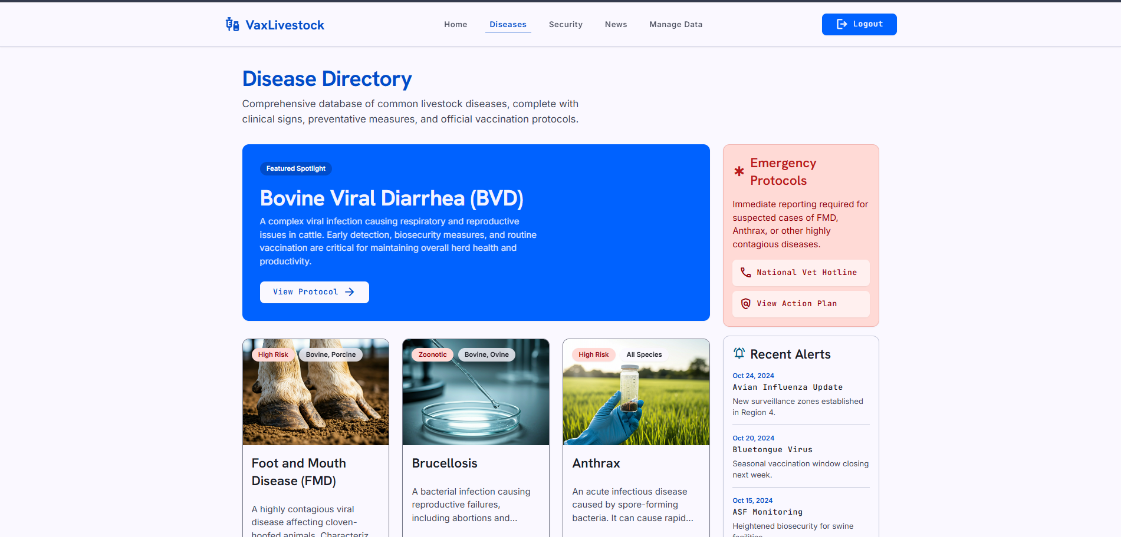

-Manage data
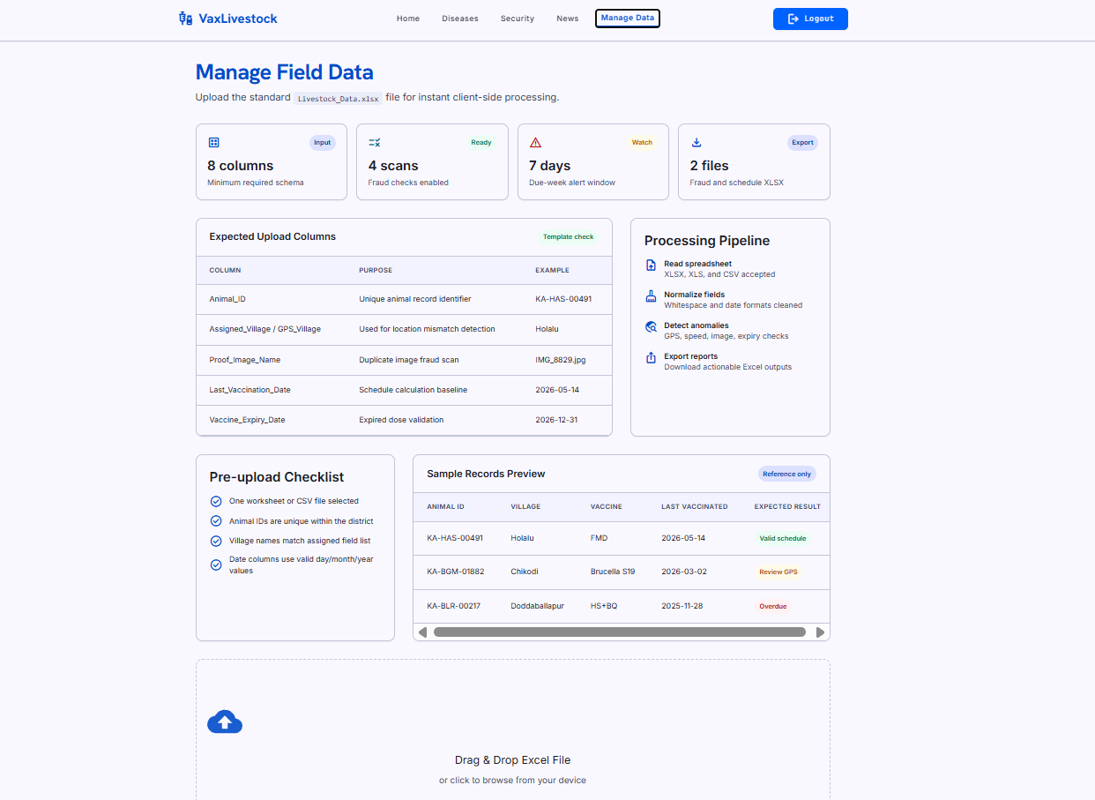

-login page
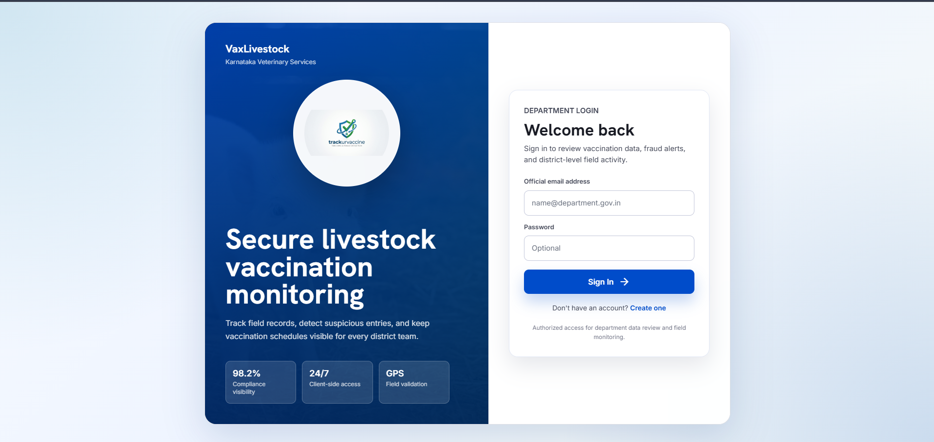

  - Faculty Feedback & Signature:

Week 13–14: Review of Users, Refining and Pre-final Review
  - User Testing Report: Tested with 3 veterinary officers and 2 district administrators using real anonymized data. Upload-to-results time: ~45 seconds.

  - Feedback Received (List out the important/crucial points):

- Show assigned vs GPS village side-by-side — implemented
- Add color legend for risk badges — added
- Improve mobile responsiveness for district grid — CSS adjusted

  - Review: Fraud engine correctly identified all 3 planted anomalous records. Core functionality validated.

  - Revisions Made:

- Responsive breakpoints for district grid (4-col → 2-col on mobile)
- Login form validation error states added
- Color contrast improved for WCAG AA accessibility
- Animated view transitions for smoother navigation

  - Faculty Feedback & Signature:

Week 15–16: Final Demo & Pitch (for CIE finalization)
  - Project/Idea Title: VaxLivestock-Smart Livestock Vaccination Monitoring & Fraud Detection Platform

  - Team Members: Nishant Yadawad.

  - Targeted Problem: No unified platform for Karnataka Veterinary Dept. to detect vaccination fraud and monitor district compliance in real-time.

  - Final Report of the Project: Attach Separately
  - Pitch Summary: Poster/PPT: https://docs.google.com/presentation/d/1gsJ0e_IW3dDL2-gRPouAhwCXoVZ0GLBv/edit?usp=sharing&ouid=111887028505266006662&rtpof=true&sd=true

  - Jury Comments:

  - Marks (out of 50):

  - Faculty Signature:

Final Reflection & Self-Assessment (Student shall answer the following questions prior to final viva-voce or presentation)

  - What did I learn from this course?

- Learned the complete end-to-end product development lifecycle — from identifying a real-world problem through user research, ideation, prototyping, iterative testing, and final deployment. Each phase demanded a different mindset: research requires patience, design requires empathy, coding requires precision, and testing requires honesty.
- Understood how government processes like livestock vaccination campaigns involve multiple stakeholders (field veterinary officers, taluk-level data operators, district administrators, state audit cells, and farmers) — each has vastly different needs, technical comfort levels, and priorities. Designing for all of them simultaneously was the hardest lesson.
- Gained deep appreciation for data integrity and fraud prevention as first-class design concerns, not features to be added later. A system that collects data without validating it can actually be worse than no system — it creates a false sense of accountability while fraud continues unchecked.
- Realized the importance of thorough domain research before writing a single line of code — understanding veterinary vaccination schedules (FMD every 6 months, Brucellosis at 4–8 months age, HS+BQ before monsoon), cold-chain temperature requirements (2–8°C), and field-level realities (intermittent connectivity, shared devices, low digital literacy) shaped every design decision in the project.
- Learned that a well-designed UI can make complex data (fraud scores, compliance metrics, scheduling alerts) understandable even to non-technical administrators. Conversely, a poorly designed UI can render even the most powerful backend useless if people can't interpret the output.
- Understood the value of working on a socially relevant problem — livestock health directly impacts the livelihoods of millions of rural families, and building technology to protect it gave the project a sense of purpose beyond academics.

  - Skills I gained:

- Frontend web development — HTML5 semantic markup, CSS3 (Grid, Flexbox, animations, media queries), JavaScript (ES6+ modules, DOM manipulation, event handling, async processing), and TailwindCSS with custom configuration
- Client-side data processing using the SheetJS (xlsx.js) library for parsing Excel and CSV files entirely in the browser without any backend server dependency
- UI/UX design following Material Design 3 principles — custom color token systems (primary, secondary, tertiary, error, surface hierarchy), typography scales (Hanken Grotesk for headings, Inter for body, JetBrains Mono for labels), and reusable component patterns (cards, badges, chips, tables, progress bars)
- Fraud detection algorithm design — conceptualizing a weighted multi-signal scoring engine, defining trigger conditions, assigning risk weights, and iterating on thresholds to balance sensitivity vs. specificity
- User testing methodology — planning test scenarios, conducting structured interviews with real veterinary professionals, collecting and categorizing feedback, and translating user pain points into actionable UI/UX revisions
- Data visualization — presenting district-level compliance through color-coded grid maps, progress bars, and status badges that communicate meaning at a glance
- Technical report writing, structured documentation, presentation design, and the ability to communicate complex technical ideas to non-technical audiences
- Team collaboration — role-based task delegation, weekly milestone tracking, conflict resolution, and coordinating parallel development across UI, data processing, and documentation tracks within a 4-member team

  - Challenges I faced and overcame:

- Inconsistent Excel formats: Different taluks and districts submitted vaccination data with varying column headers (e.g., "Village" vs. "Assigned_Village" vs. "village_name"), inconsistent date formats (DD/MM/YYYY vs. YYYY-MM-DD), and missing fields. Overcame this by implementing a flexible column-name matching system in the parser that handles common variations and prompts the user when an essential column cannot be auto-detected.
- Fraud weight calibration: Initial fraud-signal weights produced too many false positives — legitimate records were being flagged as suspicious, which would erode officer trust in the system. Overcame this through iterative testing with intentionally planted anomalous records and direct feedback from veterinary officers, eventually arriving at balanced thresholds: GPS mismatch (+40), impossible speed (+20), duplicate image (+30), expired vaccine (+50).
- Non-technical users: District administrators and senior officers found early prototypes confusing due to technical terminology like "anomaly score," "hash conflict," and "GPS delta." Overcame this by replacing all jargon with plain-language labels (e.g., "Location Mismatch" instead of "GPS Delta"), adding intuitive color-coded risk badges (green = Safe, amber = Warning, red = High Risk), and designing a guided step-by-step upload workflow with an animated progress bar and rotating fact text to keep users engaged during processing.
- Responsive design: The 12-cell district compliance grid and wide data tables broke on tablet and mobile screens, with text overflowing and columns collapsing. Overcame this by implementing systematic CSS media query breakpoints — the grid adapts from 4 columns (desktop) → 2 columns (tablet) → 1 column (mobile), and tables gain horizontal scroll on small screens.
- Performance with large datasets: Early testing with 500+ row Excel files caused noticeable UI freezes during parsing. Overcame this by adding the processing overlay with a progress bar, which provides visual feedback during computation and prevents users from thinking the application has crashed.
- Team coordination: Balancing parallel development across UI design, data processing logic, and documentation/research tracks was initially chaotic. Overcame by establishing clear weekly milestones, maintaining a shared task board, and conducting brief 15-minute sync meetings twice a week to align progress and unblock dependencies.

  - What would I do differently next time?

- Start user interviews and field visits in Week 1 itself instead of Week 3 — early domain understanding would have prevented several mid-project requirement changes and saved at least one full sprint of rework.
- Build a companion mobile-native Android app for field data collection with mandatory GPS capture, camera-based proof image with timestamp watermark, and offline-first sync — to complement this monitoring dashboard and close the loop from data entry to analysis.
- Integrate real IoT temperature sensors (e.g., ESP32 or Raspberry Pi-based with DHT22 sensors) for automated cold-chain verification, eliminating reliance on manually uploaded temperature logs which can themselves be fabricated.
- Add a lightweight backend (e.g., Firebase, Supabase, or a simple Node.js + PostgreSQL stack) so that historical vaccination data persists across sessions, enabling powerful trend analysis, year-over-year district comparison, seasonal outbreak prediction, and cumulative officer performance tracking.
- Conduct at least 3 rounds of user testing with a larger and more diverse sample — ideally 15–20 users across 5+ districts and different roles (field vets, data operators, district officers, state administrators) — rather than a single round with 5 users.
- Explore adding a real-time notification and alert system (email, SMS, or WhatsApp Business API) that automatically informs district officers and state audit cells when high-risk records are detected, rather than requiring them to actively log in and check the dashboard.
- Invest more time in accessibility — ensuring full WCAG AA compliance, keyboard navigation support, screen reader compatibility, and support for Kannada language localization for field-level users.

  - Faculty Suggestions:

